Software Requirements
Specification
for

UniHall
Prepared by

Hasan Mahmud(MUH2225007M)

MD Masum Bhuiyan(MUH2225013M)

Argha Dutta(ASH2225030M)

Tafhimul Adib(MUH2225033M)

Institute of Information Technology
Noakhali Science and Technology University

21.09.2025
Table of Contents
1. Introduction 1
1.1 Problem Statement: 1
1.2 Purpose of the Document 1
1.3 Project Scope 1
1.4 Definitions, Acronyms, and Abbreviations 2
2. Overall Description 2
2.1 Product Perspective 2
2.2 User Classes and Characteristics 3
2.3 Operating Environment 3
2.4 Design and Implementation Constraints 4
3. Functional Requirements 5
4. Non-Functional Requirements 8
4.1 Performance Requirements 8
4.2 Data Requirements 8
4.3 Dependability Requirements 8
4.4 Maintainability and Supportability Requirements 9
4.5 Security Requirements 9
4.6 Usability Requirements 9
5. Requirement Engineering Process 10
5.1 Requirement Elicitation Techniques 10
5.1.1 Hold Interviews 10
5.1.2 Perform Document Analysis 10
5.2 Sample of Requirement Collection 10
5.2.1 Requirement Collection – 1(Student) 11
5.2.2 Requirement Collection – 2(Admin) 12
5.2.3 Requirement Collection – 3(Exam Controller) 13
5.2.4 Requirement Collection – 4(Staff) 14
5.2.5 Requirement Collection – 5(DPD Section) 16
5.3 Conflict Requirement and Negotiations 17
5.4 Requirement Validation 18
5.5 Requirement Verification 18
6. Use Case Diagram 19
7. Use Case Descriptions 20
Use Case 1(Login) 20
Use Case 2(Register Account) 21
Use Case 3(Apply for Seat) 22
Use Case 4(Upload Documents) 23
Use Case 5(Apply for Renewal) 24
Use Case 6(View Shortlist) 25
Use Case 7(Attend Interview & 26
Use Case 8(Waitlist Access) 27
Use Case 9(Confirms Seat via Payment) 28
Use Case 10(Submit Complaints / Feedback) 29
Use Case 11(Notifications) 30
Use Case 12(Student view seat plan.) 31
Use Case 13(Student Logout) 32
Use Case 14(Admin login) 33
Use Case 15(Manage Applications) 34
Use Case 16(Override Allotment) 35
Use Case 17(Manage Complaints) 36
Use Case 18(Track Discipline Records) 37
Use Case 19(Manage Inventory) 38
Use Case 20(Configure Application Form) 39
Use Case 21(Dashboard) 40
Use Case 22(Approve / Deny student seat renewal requests) 41
Use Case 23(Manage Waitlist) 42
Use Case 24(Receive Admin Notifications) 43
Use Case 25(Logout) 44
Use Case 26(Exam controller login) 45
Use Case 27(Upload exam seat plan) 46
Use Case 28(Upload Exam Results) 47
Use Case 29(Logout) 48
Use Case 30(Staff login) 49
Use Case 31(Staff Complaint Management) 50
Use Case 32(Staff Complaint Notification) 51
Use Case 33(Staff Logout) 52
8. Activity Descriptions 53
Figure-1: Student Registration 53
Figure-2: Student Login 54
Figure-3: Apply Process 55
Figure-4: Upload Document 56
Figure-5: Student Interview 567
Figure-6: Payment 58
Figure-7: Renewal Seat 56
Figure-8: Student Complaint 560
Figure-9: Student Logout 61
Figure-10: Admin Login 62
Figure-11: Admin Dashboard 63
Figure-12: Admin Discipline 63
Figure-13: Admin Complaint Management 63
Figure-14: Aplication Form 63
Figure-15: Application Manage 63
Figure-16: Interview Manage 68
Figure-17: Wait List 63
Figure-18: Admin Renewal 70
Figure-19: Admin Override 71
Figure-20: Admin Logout 72
Figure-21: Exam Controller Login 73
Figure-22: Upload Exam Hall Seat Plan 74
Figure-23: Result Upload 75
Figure-24: Exam controller Logout 76
9. Sequence Diagram 77
Figure-1: Student Registration 77
Figure-2: Student Login 78
Figure-3: Apply Process 79
Figure- 4: Upload Document 80
Figure-5: Interview 81
Figure-6: Payment 82
Figure-7: Renewal Seat 83
Figure-8: Student Complaint 84
Figure-9: Student Logout 85
Figure-10: Admin Dashboard 86
Figure-11: Admin Discipline 87
Figure-12: Admin Application Form 88
Figure-13: Admin Application Manage 89
Figure-14:Wait List 90
Figure-15: Admin Override 91
Figure-16: Admin Complain Management 92
Figure-17: Exam Controller Login 93
Figure-18: Exam Controller Seat Upload 94
Figure-19: Exam Controller Result Upload 95
Figure-20: Exam Controller Logout 96
10.Class Diagram 97
11.Database Schema 98
12. Requirement Traceability Matrix 101

1. Introduction
UniHall is designed to replace the manual hall seat allotment system at Noakhali Science and Technology University (NSTU) with a transparent, efficient, and technology-driven solution. The system clearly defines its purpose, scope, and key features to serve as a foundational guide for development, testing, and communication among stakeholders including students, administrators, stuff and exam controllers.

1.1 Problem Statement:
At NSTU, the current manual approach to hall seat allocation is slow, opaque, and prone to human error. Students are required to submit paper-based forms and then wait an uncertain period for results. Administrators must manually score and shortlist candidates, which not only consumes valuable time but also introduces risks of bias or mistakes.
Furthermore, handling seat renewals, complaints, inventory and disciplinary records adds additional layers of complexity. Students receive little to no timely feedback or notifications about their application status, interview calls, or seat confirmation, leaving them in confusion and dissatisfaction.

1.2 Purpose of the Document
The primary purpose of this document is to clearly and precisely outline the software requirements for the UniHall. It aims to define the functionalities, performance criteria, and design constraints necessary for the successful development and deployment of the system. This SRS will serve as a crucial reference for the development team, quality assurance personnel, and all project stakeholders, ensuring a shared understanding of the system to be built.

1.3 Project Scope
UniHall is a web-based platform designed to improve and streamline the seat allotment process in university residential halls. The system digitizes the entire workflow including student registration, application submission, document upload, point-based shortlisting, interviews, seat allotment, payments, renewals, waitlist management, and complaints.
Key functions include:
- Automated scoring algorithm for transparent shortlisting.
- Interview scheduling and final selection updates by administrators.
- Online payment system for seat confirmation.
- Renewal and waitlist handling.
- Integrated complaint management system with multimedia support.
- Notifications for all major events (shortlisting, interviews, allotments, payments, renewals, complaints).
- Role-based access for Students, Admins, and Exam Controllers.
The system aims to reduce paperwork, increase transparency, and enhance student residential management.

1.4 Definitions, Acronyms, and Abbreviations
The following table defines the terms and abbreviations used throughout this document:
Term | Definition
UniHall | University Hall Seat Allotment System
OTP | One-Time Password used for secure registration/login
CGPA | Cumulative Grade Point Avarage
Admin | University authority responsible for managing applications, allotments, and complaints.
Exam controller | University official responsible for uploading exam results and seat plans.
Student Portal | The online interface for students to interact with the system.
Staff | Assigned personnel responsible for receiving, reviewing, and resolving student complaints.

2. Overall Description

2.1 Product Perspective
UniHall is a standalone web-based system but can integrate with existing university databases (e.g., student information, academic records). It follows a client-server architecture, where the client side is accessible via web browsers on desktops and mobile devices, and the server side handles processing, data management, and storage.
The system ensures scalability and security through role-based access and encrypted communications.

2.2 User Classes and Characteristics

The system is designed to cater to various user types, each with distinct needs and technical characteristics:
User Type | Description
Students | - Primary users of the system.  - Apply for hall allotment, upload documents, track shortlisting status , attend interviews, confirm seats, renew, and submit complaints.  - Require a user-friendly interface accessible via mobile and desktop.
Admin | - University hall authority.  - Manage applications, shortlisting, interviews, allotments, renewals, waitlists, inventory, and complaints.  - Require access to dashboards, reports, and advanced configuration options.
Staff | - Assigned personnel responsible for receiving, reviewing, and resolving student complaints
Exam Controllers | - University officials responsible for uploading exam results and seat plans.  - Require limited but secure access to upload relevant files.

2.3 Operating Environment
The UniHall is designed to operate across various platforms and in diverse environmental conditions. The specified operating environment includes:
- Frontend: HTML, CSS, JavaScript, React
- Backend: Node.js with Express.js framework
- Platform: Web Version of Desktop and Mobile.
- Payment Integration: Must comply with Bangladesh Bank e-payment guidelines.

2.4 Design and Implementation Constraints
Several design and implementation constraints will govern the development of the UniHall to ensure its robustness, security, and maintainability:
- Programming Languages:
- Backend services will primarily use Node.js and Express.
- Frontend development will use HTML, CSS, JavaScript, and React to build responsive and interactive user interfaces. Frontend development for web and mobile interfaces will use JavaScript .
- SQL queries and schema design will be written for MySQL to manage relational data.

- APIs:
- An Email API (e.g., Nodemailer / SMTP or third-party service like SendGrid) will be integrated to send OTP (One-Time Passwords) for account verification and password recovery.
- Payment Gateway APIs will be integrated, supporting SSLCommerz or bKash for secure online transactions.

- Security:
- User authentication will follow secure practices, including hashed passwords and JWT (JSON Web Tokens) for session management.

- Database:
- MySQL will be used for structured data storage, ensuring relational integrity and optimized query performance.

- Legal Compliance:
- Student data shall be handled in compliance with local data protection regulations (Bangladesh ICT Act 2006, GDPR principles for global standards).

3. Functional Requirements
Functional requirements for UniHall define the specific behaviors and functionalities the system must exhibit to achieve its objectives.
ID | Requirement | User Story
FR001 | Student Registration & Login | As a student, I want to register and log in using my University ID, email, and OTP so that I can securely access the UniHall system.
FR002 | Application Submission | As a student, I want to fill out and submit a customizable hall application form so that I can apply for seat allotment.
FR003 | Document Upload | As a student, I want to upload supporting documents (transcripts, proof, photo) so that my application can be validated.
FR004 | View Shortlist | As a student, I want to view the published shortlist with selection criteria so that I can see if I am selected for an interview.
FR005 | Interview Attendance & Results | As a shortlisted student, I want to be notified of interviews and view my final result so that I know if I have been allotted a seat.
FR006 | Seat Confirmation & Payment | As a student, I want to pay online for my allotted seat so that I can confirm my hall accommodation.
FR007 | Waitlist Management (Student Side) | As a student on the waitlist, I want to receive notifications if a seat becomes available so that I can confirm it.
FR008 | Complaint/Feedback Submission | As a student, I want to submit complaints or feedback with attachments so that issues can be tracked and resolved
FR009 | Renewal Requests | As a current resident, I want to apply for hall renewal so that I can continue staying in the hall next term.
FR010 | Student Notifications | As a student, I want to receive alerts for interviews, results, payments, renewals, and waitlist updates so that I stay informed.
FR011 | Administrator Login | As an administrator, I want to log in securely with role-based credentials so that I can access my assigned modules.
FR012 | Manage Applications | As an admin, I want to review and verify student applications and documents so that I can make informed decisions.
FR013 | Automated Scoring & Shortlist Generation | As an admin, I want the system to automatically score applications and generate a shortlist so that selection is fair and efficient.
FR014 | Manage Interviews & Final Selection | As an admin, I want to update interview outcomes and finalize allotments so that students are assigned seats properly.
FR015 | Override Allotment | As an admin, I want to manually override seat allocations so that I can handle special cases or corrections.
FR016 | Manage Complaints (Admin) | As an admin, I want to track and resolve student complaints so that issues are addressed efficiently.
FR017 | Track Discipline Records | As an admin, I want to maintain and view student misconduct records so that discipline can affect eligibility.
FR018 | Manage Inventory | As an admin, I want to update and track hall assets so that I can maintain accurate inventory records.
FR019 | Configure Application Form | As an admin, I want to modify the hall application form fields each session so that requirements remain up to date.
FR020 | Dashboard & Reports | As an admin, I want to view real-time statistics and generate reports so that I can monitor hall usage and occupancy.
FR021 | Manage Renewals (Admin) | As an admin, I want to review and approve/deny renewal requests so that only eligible students continue their stay.
FR022 | Manage Waitlist (Admin) | As an admin, I want to allocate freed seats to waitlisted students so that no hall capacity goes unused.
FR023 | Administrator Notifications | As an admin, I want to be notified of new complaints, renewals, and exam results so that I can take timely action
FR024 | Upload Exam Results | As an exam controller, I want to upload student exam results so that the system can use them in seat allocation.
FR025 | Upload Exam Seat Plan | As an exam controller, I want to upload exam seating arrangements so that students and admins can access them for planning.
FR026 | Staff Login | As a Staff member, I want to securely log in with my credentials so that I can access and manage student complaints.
FR027 | Manage Complaints | As a Staff member, I want to view, update, and resolve student complaints so that I can address issues effectively.
FR028 | Staff Notifications | As a Staff member, I want to receive notifications when a new complaint or feedback is submitted so that I can take timely action.
FR029 | Staff Logout | As a Staff member, I want to securely log out of the system so that my account remains protected after use.

4. Non-Functional Requirements
Non-functional requirements specify criteria that can be used to judge the operation of a system, rather than specific behaviors.

4.1 Performance Requirements
- PR1: The system shall process and display search results (e.g., shortlist view) within 3 seconds under normal load.
- PR3: The Document uploads up to 20 MB per file shall be processed and stored within 5 seconds.

4.2 Data Requirements
- DR1: All application, payment, and complaint data shall be stored in a centralized MySQL database.
- DR2: Act Data storage shall comply with ACID (Atomicity, Consistency, Isolation, Durability) properties to ensure integrity.
- DR3: Uploaded documents (transcripts, proofs, photos) shall be stored securely

4.3 Dependability Requirements
- DPR1: The system must achieve 99.9% uptime.
- DPR2: Notifications and critical operations (shortlist publishing, payments) must remain available during peak load.
- DPR3: The system shall continue operating normally even if one server or database node becomes unavailable.

4.4 Maintainability and Supportability Requirements
- MSR1: The system shall be built with modular architecture (frontend, backend, database, APIs) to allow easy updates.
- MSR2: Code shall follow industry-standard coding practices (React for frontend, Node.js/Express for backend) for maintainability.
- MSR3: The system shall include API documentation and developer guidelines to support future enhancements.

4.5 Security Requirements
- SR1: User authentication shall be based on OTP (for registration) and secure login credentials.
- SR2: Sensitive information (passwords, payment data) shall be stored using hashing & encryption techniques.
- SR3: The system shall implement Role-Based Access Control (RBAC) with roles: Student, Admin, Exam Controller.

4.6 Usability Requirements
- USR1: The system shall provide a responsive and mobile-friendly interface accessible on desktops, tablets, and smartphones.
- USR2: The student portal shall follow intuitive navigation with clear instructions for applications, payments, and complaints.

5. Requirement Engineering Process

Software requirements are established using requirements engineering (RE), which involves understanding and capturing customer needs or requirements. The requirements engineering process includes several key steps:
- Requirement elicitation techniques
- Requirement validation

5.1 Requirement Elicitation Techniques
Requirement elicitation, also known as "requirement gathering," is the process of investigating and discovering system requirements from users, clients, and other stakeholders. Various techniques can be employed to elicit requirements effectively:

5.1.1 Hold Interviews

Interviews are one-on-one or small group discussions with stakeholders to gather program criteria. These sessions help in obtaining specific demands from participants and identifying any conflicts or issues.
- Short description about project
- Product details
- Dealing with student, provost, staff & exam controller
- Feedback system

5.1.2 Perform Document Analysis

Document analysis is a requirement elicitation technique that involves examining existing documentation related to the system to understand its functionalities, constraints, and user requirements. Analysis can help to determine which performance should remain and functionality that isn’t in use. This technique is particularly useful for gaining insights into how the current system operates, identifying areas for improvement, and understanding stakeholder needs without directly interacting with them.

5.2 Sample of Requirement Collection
The process of requirement collection serves as a foundational step in the development of the UniHall project, providing crucial insights into the needs, preferences, and expectations of key stakeholders. This document presents an introduction to a sample requirement collection process conducted for the UniHall system, focusing on gathering insights from both students and hall administrators and others.
Requirement collection involves systematically gathering and analyzing information from stakeholders to identify essential features and functionalities for the proposed UniHall platform. Through a combination of structured interviews, surveys, and document analysis, the goal is to gain a comprehensive understanding of the user requirements and system constraints.

5.2.1 Requirement Collection – 1(Student)
The requirement collection phase of the UniHall project focused on understanding student needs for the student-facing portal.
Interview
Methodology:
- Structured interviews with a fixed set of questions
- Conducted in-person (classrooms, dormitories) and online (Google Form )
- Session length 10–15 minutes
- Responses recorded and thematically analyzed
Participants:
- 40 students from 4 academic years
- Mix of genders and departments
- All had access to smartphones/laptops with regular internet
Findings:
- Strong preference for a simple, web-based interface with clear and intuitive navigation accessible from both desktop and mobile browsers.
- Desire for transparent shortlisting criteria (CGPA, year, discipline points)
- Need notifications for shortlist, interview, allotment, renewal, and payments
- Students want the ability to upload required documents (transcripts, enrollment proof) easily
- Complaints/feedback should include image/video attachments and status tracking
- Renewal process should be quick, with clear eligibility checks
- Students fear unfair allotments and request visible criteria and shortlist publication
- Payment process must be secure and easy.

Key Requirements:
- Student portal with secure login (OTP/email verification)
- Transparent, point-based shortlisting algorithm with published criteria
- Notification system for all major updates (interview calls, allotments, renewals, payments)
- Document upload functionality with validation
- Online payment system
- Complaint/feedback submission with attachments and resolution tracking
- Renewal request module
Limitations:
- Sample size of 40 students may not capture all academic backgrounds
- Limited interviews with final-year students due to exam schedules
- Interviews conducted during one semester may bias towards specific allocation periods
Conclusion:
Student input confirms the need for a simple, mobile-friendly portal with transparent shortlisting, secure payments, notifications, complaint handling, and renewal support. Transparency, fairness, and usability are critical for adoption. These requirements will guide the design and iterative testing of UniHall.

5.2.2 Requirement Collection – 2(Admin)
The second phase of requirement collection for the UniHall project focused on understanding the needs of administrators who manage student applications, shortlists, interviews, renewals, inventory, and complaints.
Interview
Methodology:
- Semi-structured interviews with open and fixed questions
- Conducted in administrative offices (in-person) and follow-up phone calls
- Session length 15–20 minutes
- Notes recorded, categorized, and analyzed for common themes
Participants:
- Hall administrators (Provost, Assistant Provosts, Senior Hall Officers)
- Staff supporting hall management systems

Findings:
- Strong need for a centralized dashboard to monitor applications and occupancy
- Preference for an automated shortlisting with manual override options in special cases
- Renewal request management (approve/deny) with eligibility checks Desire for complaint tracking system that allows prioritization and status monitoring
- Need for hall asset tracking with simple inventory updates
- Reports/analytics required for decision-making (applications, vacancies, confirmed seats)
- Importance of notifications for new complaints, renewal requests, and exam result uploads
- Emphasis on data security and role-based access to prevent unauthorized access
Key Requirements:
- Secure admin login with role-based access
- Dashboard with statistics and hall occupancy status
- Automated scoring and shortlist generation (CGPA, year, discipline)
- Manual override option for special cases in allotments
- Renewal management module with eligibility validation
- Complaint management system with tracking and resolution notes
- Inventory management system for hall resources
- Discipline record tracking (misconduct logs)
- Reports and analytics generation (applications, shortlists, renewals, occupancy)
- Notification system for new complaints, renewals, and exam controller updates
Assumptions:
- Administrators have continuous access to computers with internet connectivity
- University authority approves use of automated scoring rules and override options
- Inventory and student misconduct records can be digitized into the system
Limitations:
- Small sample size may not capture all policy variations across halls
- Missing prototype testing of dashboards during interviews
Conclusion:
Administrator input highlights the importance of a centralized, transparent, and flexible management system. Critical requirements include automated but overrideable shortlisting, complaint/renewal/inventory management, real-time notifications, and secure role-based access. These inputs will shape the design of the admin dashboard and reporting modules of UniHall.

5.2.3 Requirement Collection – 3(Exam Controller)
The third phase of requirement collection for the UniHall project focused on understanding the needs of the Exam Controller, who manages exam results and seating plans within the system.
Interview
Methodology:
- Semi-structured interviews with a short questionnaire and open-ended discussions
- Conducted at the Exam Controller’s office
- Session length 20–30 minutes
- Key points summarized and validated with participants
Participants:
- 2 senior officials from the Exam Controller’s office
- Regular users of institutional academic result management systems
Findings:
- Need a secure and simple upload module of exam results for hall
- Ability to upload and manage exam seating arrangements within the portal
- Emphasized data accuracy and strict access control (only authorized exam staff should upload/modify results)
- Need for a simple interface with minimal steps for uploads, to avoid errors under time pressure
Key Requirements:
- Secure login for exam controller with restricted permissions
- Upload functionality for exam results
- Upload functionality for exam seating plans
Assumptions:
- Exam office staff are comfortable using basic digital tools (file uploads)
Limitations:
- Small sample size (2 officials) may not represent all operational variations across departments
- Due to confidentiality concerns, live exam result data could not be used during requirement interviews
- Limited exposure to web-based systems may require additional user training
Conclusion:
Exam Controller input confirms the need for a secure, easy-to-use, and integrated module for exam data handling. Critical features include result uploads, seat plan uploads, notifications to admins, and strict access control. These requirements ensure exam-related processes are efficiently and securely managed within UniHall.

5.2.4 Requirement Collection – 4(Staff)
The fourth phase of requirement collection for the UniHall project focused on the needs of hall support staff, who assist administrators by handling student complaints, tracking hall inventory.
Interview
Methodology:
- Focus group discussion and short interviews with hall clerical/support staff
- Conducted in hall offices and storage areas
- Session length 15–25 minutes
- Feedback summarized into common themes
Participants:
- Hall clerical staff (responsible for logging complaints and basic admin work)
- Support staff responsible for inventory checks (beds, furniture, appliances)
- Mix of experienced staff and assistants
Findings:
- Need for a simple and structured complaint management interface to log, update, and track complaints efficiently
- Desire for clear categorization of complaints (e.g., maintenance, discipline, facilities) to prioritize tasks
- Staff want the ability to upload resolution notes or mark complaints as resolved so students can see updates
- For inventory, staff require easy data entry and update options for hall resources (beds, tables, appliances)
- Need to track damaged or missing assets and mark them for repair or replacement
- Emphasis on ease of use since some staff are not highly tech-savvy
- Require notifications for new complaints assigned to staff or when inventory updates are due
Key Requirements:
- Complaint management module with categorization, status updates, and resolution tracking
- Inventory management module with add/update/remove functions for assets
- Ability to mark assets as “damaged,” “under repair,” or “replaced”
- Notifications for new complaint assignments and important inventory updates
- Role-based restricted access (staff can only manage complaints and inventory, not allotments)
Assumptions:
- Staff use desktops or shared hall computers to access the system
- Administrators will assign complaints and inventory tasks to specific staff users
- Inventory lists are already available in physical form and can be digitized during onboarding
Limitations:
- Limited digital literacy among some staff may require training sessions
- Smaller sample size may not capture all operational differences across halls
- Dependency on administrators to assign tasks properly in the system
Conclusion:
Staff input emphasizes the need for a simple, role-focused module that allows efficient complaint resolution and inventory tracking. Critical features include categorization, asset condition tracking, and targeted notifications. These requirements ensure hall staff can support administrators effectively while improving student satisfaction and hall resource management.

5.2.5 Requirement Collection – 5(DPD Section)
The fifth phase of requirement collection for the UniHall project focused on the Department of Planning and Development (DPD), which oversees hall inventory, facilities, and resource planning.
Interview
Methodology:
- Interview conducted with the Chief Engineer of the DPD section
- Conducted in DPD office
- Session length: 20 minutes
- Feedback summarized into main observations
Participants:
- 1 Chief Engineer of the DPD section responsible for hall facilities, inventory, and planning
Findings:
- Requests for maintenance or hall development are routed through multiple departments (e.g., civil, electrical, mechanical)
- Large-scale maintenance or procurement requires tendering processes
- Current workflow is complex, requiring coordination across several departments and formal approvals
- Due to the scale and resource constraints, the full DPD workflow cannot be implemented in this project

Key Requirements (for current project scope):
- The project will not include detailed DPD workflow (multi-department requests, tender processing)
- Only basic inventory viewing or summary information from hall staff can be considered if necessary
- Focus remains on modules for students, hall staff, and exam controllers

Assumptions:
- Detailed DPD operations are outside the scope due to time and resource limitations
- Any future integration with DPD workflow can be considered in subsequent versions of the system
Limitations:
- Full hall planning and tender processes are not modeled in the current system
- DPD-related approvals, departmental coordination, and tender tracking are excluded
Conclusion:
Based on the interview with the Chief Engineer, it was decided to skip detailed DPD workflows in this project due to complexity and resource constraints. The project will focus on modules for hall staff, students, and exam controllers, while leaving DPD’s full inventory planning and multi-department coordination for future enhancements.

5.3 Conflict Requirement and Negotiations
During requirements elicitation, some conflicting requirements were identified:
- Complaint Management (Staff vs. Admin)
  - Initial requirement suggested Admin would handle complaints.
  - Staff interviews revealed that minor issues (e.g., broken lights/fans) are more efficiently handled by staff without admin intervention.
  - Conflict Resolution: Introduced a new actor Staff responsible for complaint management, while Admin focuses on higher-level tasks.
- DPD Section Involvement
  - DPD section staff explained a complicated manual process that was difficult to automate in UniHall’s current scope.
  - Conflict Resolution: DPD process was excluded from the system to reduce complexity. Complaint handling was reassigned to staff only.
- CCTV Feature Requested by Provost
  - The provost suggested adding a CCTV integration feature.
  - This requirement conflicted with project constraints (time, cost, scope).
Conflict Resolution: CCTV integration was removed after negotiation, as it exceeded project scope

5.4 Requirement Validation
Requirement validation ensured that the documented requirements reflected stakeholder needs:
- Stakeholder Review: Draft SRS was reviewed by Students, Admin, and Staff for accuracy.
- Consistency Check: Verified no contradiction between student-side, admin-side, and staff-side requirements.
- Completeness Check: Ensured all functional requirements (e.g., seat allocation, complaint resolution, notifications) were covered.
- Traceability Matrix: Maintained mapping between functional requirements and their sources (interview notes, stakeholder feedback).

5.5 Requirement Verification
Requirement verification focused on ensuring that requirements were technically feasible and testable:
- Feasibility Analysis:
  - Checked if requirements (online payment, OTP verification, notifications) could be implemented with selected tech stack (React, Node.js, Express, MySQL, SSLCommerz/ Bkash, Email API).
- Testability Check:
  - Each requirement was written in measurable terms (e.g., "System must send OTP within 30 seconds").
- Consistency with Non-Functional Requirements:
  - Verified scalability (5,000 concurrent users), security (role-based access, encryption), and availability.
- Review by Development Team:
  - Cross-checked requirements with developers to ensure implementation within deadlines.

6. Use Case Diagram

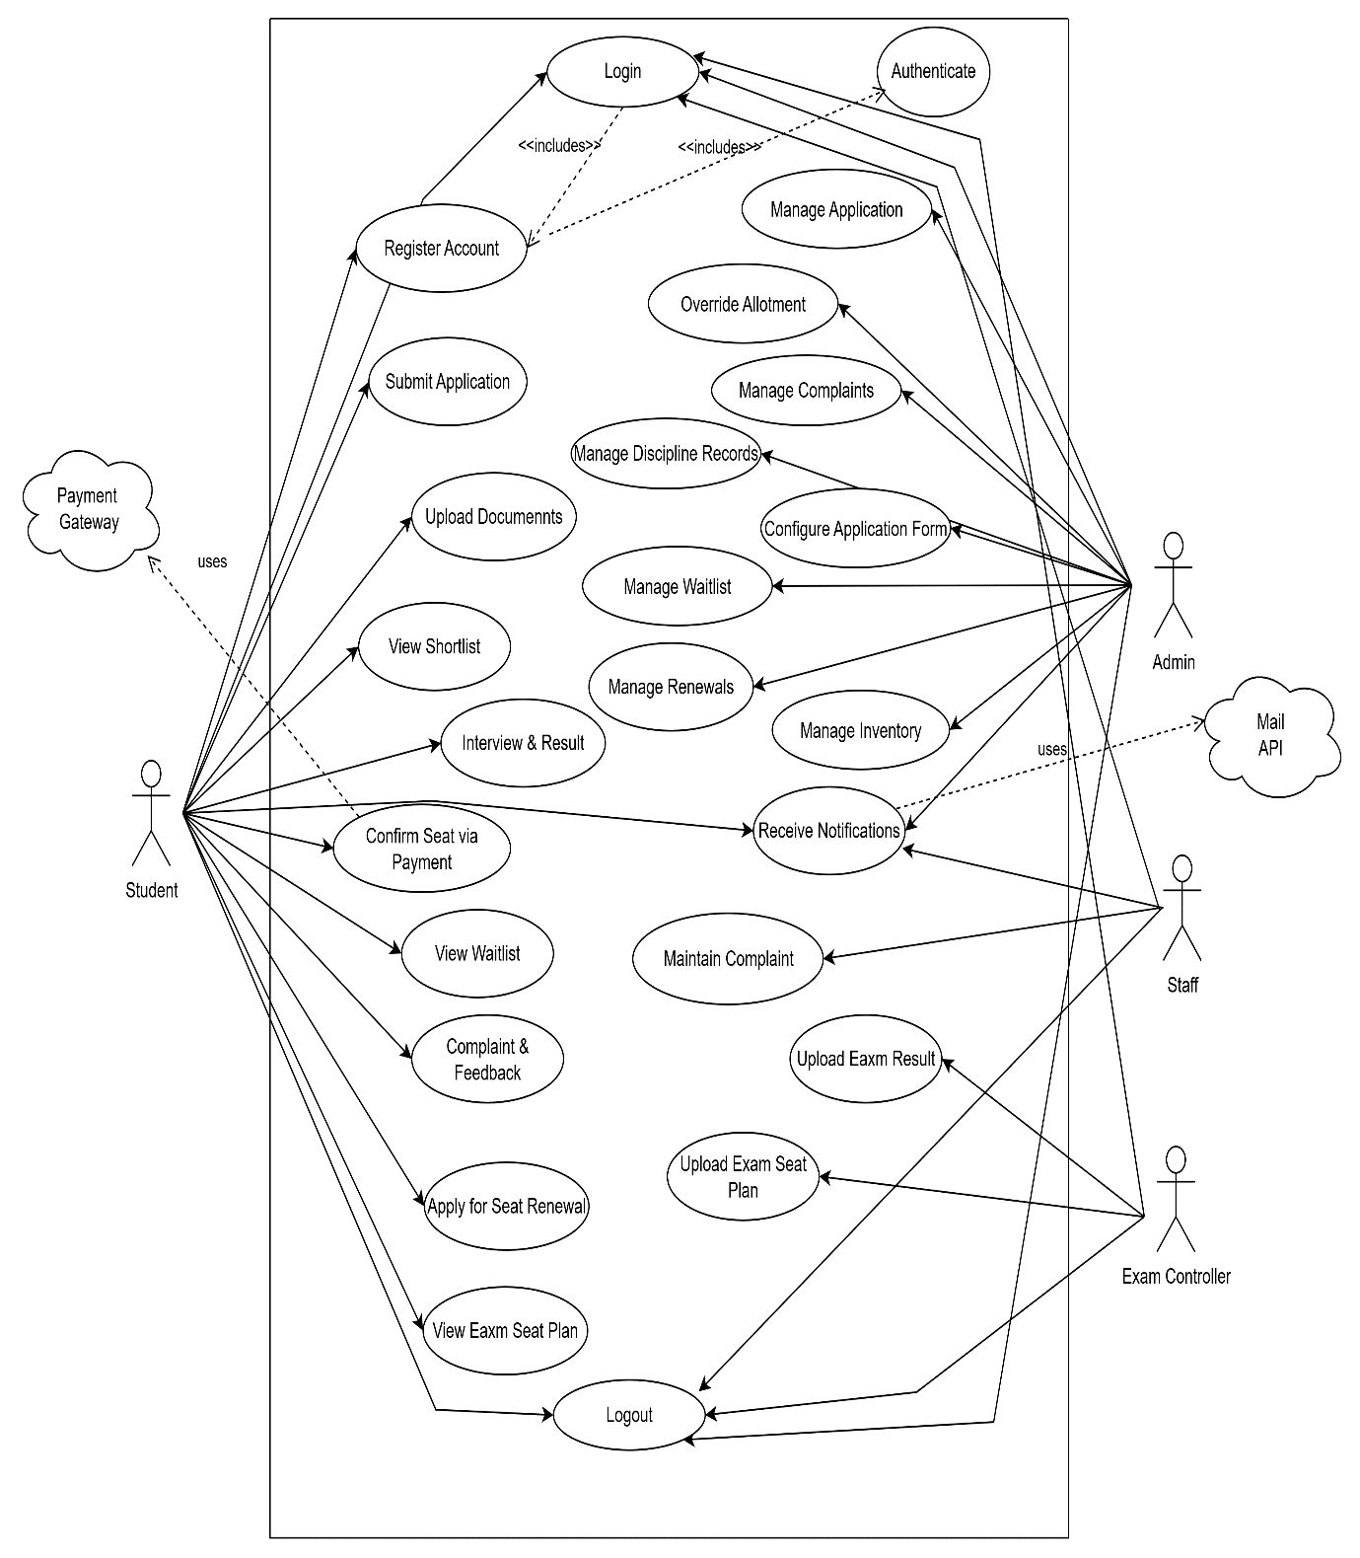

Figure-1: Use Case Diagram

7. Use Case Descriptions
All use cases from use case diagram are explained here.

Table 7.1: Student Login

Use Case 1 | Login
Goal | Student logs into the UniHall system securely.
Preconditions | Student has a registered account
Success End Condition | Student is authenticated and gains access to the dashboard.
Failed End Condition | Student cannot access the system due to invalid credentials.
Primary Actors: Secondary Actors: | Students  System
Trigger | Student selects "Login" option on portal
Main Success Flows | Step | Action
 | 1 | Student enters University ID and password.
 | 2 | System validates credentials.
 | 3 | Student is redirected to the dashboard.
Alternative Flows | Step | Branching Action
 | 1 | If credentials are invalid, system shows error and prompts retry
Quality Requirements | Step | Requirement
 | 3 | Passwords must be securely encrypted.

Table 7.2: Register Account

Use Case 2 | Register Account
Goal | Student registers for a new UniHall account.
Preconditions | Student has valid University ID and email.
Success End Condition | Student account is successfully created.
Failed End Condition | Student cannot create account due to invalid/missing data.
Primary Actors: Secondary Actors: | Student  System
Trigger | Student selects “Register Account” option.
Main Success Flows | Step | Action
 | 1 | Student clicks Register Account.
 | 2 | Student enters ID, email, password, and details.
 | 3 | System sends OTP to email.
 | 4 | Students verifies OTP.
 | 5 | Account is activated.
Alternative Flows | Step | Branching Action
 | 3a | If OTP verification fails, account is not created.
 | 2a | If email/ID already exists, system shows error.
Quality Requirement | Step | Requirement
 | 1 | OTP should expire after a set time (e.g., 5 minutes).

Table 7.3: Apply for Seat

Use Case 3 | Apply for Seat
Goal | Student applies for a hall seat.
Preconditions | Student is logged in and has an active account.
Success End Condition | Application is submitted successfully.
Failed End Condition | Application is not submitted due to missing/invalid information.
Primary Actors: Secondary Actors: | Student  System
Trigger | Student selects “Apply for Seat”.
Main Success Flows | Step | Action
 | 1 | Student opens Apply for Seat form.
 | 2 | Enters academic year, CGPA, and required details.
 | 3 | Uploads necessary documents
 | 4 | Submits application.
 | 5 | System confirms submission.
Alternative Flows | Step | Branching Action
 | 5a | If required fields are missing, system prompts to complete them.
 | 5b | If deadline has passed, application is rejected.
Quality Requirement | Step | Requirement
 | 5a1 | Application data must be validated.
 | 5a2 | System must prevent supplicate submissions.

Table 7.4: Upload Documents

Use Case 4 | Upload Documents
Goal | Student uploads required documents for application.
Preconditions | Student has valid documents in digital format.
Success End Condition | Documents are uploaded and linked to the student’s application.
Failed End Condition | Documents are not uploaded or corrupted.
Primary Actors: Secondary Actors: | Student  System
Trigger | Student selects “Upload Documents”.
Main Success Flows | Step | Action
 | 1 | Student selects Upload Documents option.
 | 2 | Chooses transcript, enrollment proof, or other files.
 | 3 | System validates file format and size.
 | 4 | Files are uploaded and stored.
 | 5 | System confirms upload.
Alternative Flows | Step | Branching Action
 | 3a | If unsupported format, system prompts for valid format.
Quality Requirements | Step | Requirement
 | 3a | Supported formats: PDF, JPG, PNG.
 | 3b | Maximum upload size defined

Table 7.5: Apply for Renewal

Use Case 5 | Apply for Renewal
Goal | Student requests renewal of hall seat for the next session.
Preconditions | Student already has a seat.
Success End Condition | Renewal request is submitted.
Failed End Condition | Renewal request is denied due to eligibility failure.
Primary Actors: Secondary Actors: | Student  System
Trigger | Stakeholder selects “Apply for Renewal”
Main Success Flows | Step | Action
 | 1 | Student opens Renewal Request form.
 | 2 | Fills in required details.
 | 3 | System checks eligibility (discipline, Term).
 | 4 | Renewal Request submitted.
Alternative Flows | Step | Branching Action
 | 1a | If not eligible, system rejects request.
Quality Requirement | Step | Requirement
 | 1a1 | Renewal rules must be configurable by admin.
 | 4a | Students must be notified of approval/rejection.
 | 4b | Data must be linked to previous seat record.

Table 7.6: View Shortlist

Use Case 6 | View Shortlist.
Goal | Enable students to see shortlist results for interview eligibility.
Preconditions | Admin must have published the shortlist.
Success End Condition | Student views their shortlist status.
Failed End Condition | Shortlist not published yet.
Primary Actors: Secondary Actors: | Students, Admin  System
Trigger | Students selects “View Shortlist” option.
Main Success Flows | Step | Action
 | 1 | System displays shortlist results.
 | 2 | Student sees if selected or not.
Alternative Flows | Step | Branching Action
 | 1a | If shortlist not available, system shows “Not published yet.”
Quality Requirements | Step | Requirement
 |  | Transparency—criteria displayed clearly.

Table 7.7: Attend Interview & View Results

Use Case 7 | Attend Interview & View Results
Goal | Notify shortlisted students about interviews and show final results.
Preconditions | Student must be shortlisted.
Success End Condition | Student views interview call and final results.
Failed End Condition | Student not shortlisted.
Primary Actors:  Secondary Actors: | Student, Admin  System
Trigger | Student checks notifications.
Main Success Flows | Step | Action
 | 1 | Student receives interview notification.
 | 2 | Attends interview offline.
 | 3 | Admin updates results in system.
 | 4 | Student views selection status online.
Alternative Flows | Step | Branching Action
 | 2a | If student misses interview, system marks as not selected.
Quality Requirements | Step | Requirement
 |  | Real time result updates.

Table 7.8: Waitlist Access

Use Case 8 | Waitlist Access
Goal | Provide waitlisted students with updates and automatic promotions.
Preconditions | Student must be on waitlist.
Success End Condition | Student notifies of promotion or status.
Failed End Condition | No available seat.
Primary Actors: Secondary Actors: | Student  System
Trigger | Admin publishes result.
Main Success Flows | Step | Action
 | 1 | Student checks waitlist.
 | 2 | If promoted system notifies.
Alternative Flows | Step | Branching Action
 | 2a | If not promoted, student remains on waitlist
Quality Requirement | Step | Requirement
 |  | Automatic fair reassignment of vacant seats.

Table 7.9: Confirm Seat via Payment

Use Case 9 | Confirms Seat via Payment.
Goal | Stud Allow selected students to confirm seat by online payment.
Preconditions | Syst Student must be selected.
Success End Condition | Seat confirmed and payment recorded.
Failed End Condition | Payment failure
Primary Actors: Secondary Actors: | Student, Payment Gateway
Trigger | Student clicks “Confirm Seat.”
Main Success Flows | Step | Action
 | 1 | Student selects payment method.
 | 2 | Completes transaction.
 | 3 | System verifies payment.
 | 4 | Seat allotment confirmed.
Alternative Flows | Step | Branching Action
 | 3a | If payment fails, system promts retry.
Quality Requirement | Step | Requirement
 |  | Secure online transaction.

Table 7.10: Submit Complaints / Feedback

Use Case 10 | Submit Complaints / Feedback
Goal | Allow students to submit issues/feedback with optional media.
Preconditions | Student must be logged in.
Success End Condition | Complaint submitted and tracked.
Failed End Condition | Invalid complaint or upload failure.
Primary Actors: Secondary Actors: | Student, Admin  System
Trigger | Student clicks “Submit Complaint.”
Main Success Flows | Step | Action
 | 1 | Student writes complaint.
 | 2 | Optionally uploads image/video.
 | 3 | System logs complaint and assigns to admin
Alternative Flows | Step | Branching Action
 | 2a | If file invalid, system rejects upload.
Quality Requirements | Step | Requirement
 | 3a | Real-time status updates.

Table 7.11: Notifications

Use Case 11 | Notifications
Goal | Keep students updated on all activities.
Preconditions | Student must be registered.
Success End Condition | Student receives timely notifications.
Failed End Condition | Notification delay or failure.
Primary Actors: Secondary Actors: | Student.  System
Trigger | Events (Seat Results, File submission, Complaints update)
Main Success Flows | Step | Action
 | 1 | System generates notifications.
 | 2 | Student receives and views.
Alternative Flows | Step | Branching Action
 | 1a | If offline, notification stored and delivered later.
Quality Requirements | Step | Requirement
 |  | Real-time push alerts.

Table 7.12: View Seat Plan

Use Case 12 | Student view seat plan.
Goal | Allow students to view their allocated exam seat plan.
Preconditions | Student is logged into the system.
Success End Condition | Student can successfully view the allocated seat details.
Failed End Condition | Seat plan not available or system error occurs.
Primary Actors: Secondary Actors: | Student.  System
Trigger | Students selects the option to view seat plan.
Main Success Flows | Step | Action
 | 1 | Student clicks on “View Seat Plan.”
 | 2 | System retrieves the student’s seat plan.
 | 3 | System displays the seat plan details.
Alternative Flows | Step | Branching Action
 | 3a | If no seat plan is uploaded, system shows “Seat Plan Not Available.”
Quality Requirements | Step | Requirement
 |  | Real-time push alerts.

Table 7.13: Student Logout

Use Case 13 | Student Logout.
Goal | Allow students to securely end their session.
Preconditions | Student is logged into the system
Success End Condition | Session ends and system redirects to the login page.
Failed End Condition | Session not terminated properly.
Primary Actors: Secondary Actors: | Student.  System
Trigger | Student Clicks “Logout”.
Main Success Flows | Step | Action
 | 1 | Student clicks logout option.
 | 2 | System terminates the active session.
 | 3 | Student is redirected to the login page.
Alternative Flows | Step | Branching Action
 | 1a | Session timeout → System auto-logs out the student.
Quality Requirements | Step | Requirement
 |  | Real-time push alerts.

Table 7.14: Admin login

Use Case 14 | Admin login
Goal | Allow administrators to securely log into the UniHall system.
Preconditions | Admin must have valid credentials.
Success End Condition | Admin is logged into dashboard.
Failed End Condition | Invalid credentials, login denied.
Primary Actors: Secondary Actors: | Admin  System
Trigger | Admin accesses login page.
Main Success Flows | Step | Action
 | 1 | Admin enters username and password.
 | 2 | System verifies credentials.
 | 3 | Admin gains access to dashboard.
Alternative Flows | Step | Branching Action
 | 1a | Invalid login.
Quality Requirement | Step | Requirement
 |  | Encrypted credentials.

Table 7.15: Manage Applications

Use Case 15 | Manage Applications.
Goal | Review and verify student applications and documents.
Preconditions | Students must have submitted applications
Success End Condition | Applications verified and processed.
Failed End Condition | Missing or invalid documents.
Primary Actors: Secondary Actors: | Admin  System
Trigger | Admin selects “Manage Applications.”
Main Success Flows | Step | Action
 | 1 | Admin views list of applications.
 | 2 | Checks submitted forms and documents.
 | 4 | Approves or rejects application.
Alternative Flows | Step | Branching Action
 | 1a | Incomplete application, system flags for correction.
Quality Requirements | Step | Requirement

Table 7.16: Override Allotment

Use Case 16 | Override Allotment
Goal | Allow manual seat adjustments for special cases.
Preconditions | Allotment list already generated.
Success End Condition | Manual allotment updated.
Failed End Condition | Invalid override request.
Primary Actors: Secondary Actors: | Admin, System
Trigger | Admin selects “Override Allotment.”
Main Success Flows | Step | Action
 | 1 | Admin selects student record.
 | 2 | Updates seat assignment.
 | 3 | System confirms changes.
Alternative Flows | Step | Branching Action
 | 2a | System rejects if seat unavailabe.
Quality Requirements | Step | Requirement
 |  | Not applicable.

Table 7.17: Manage Complaints

Use Case 17 | Manage Complaints
Goal | Track, review, and resolve student complaints.
Preconditions | Student must have submitted a complaint.
Success End Condition | Complaint resolved and student notified.
Failed End Condition | Complaint left unresolved.
Primary Actors: Secondary Actors: | Admin, Student  System
Trigger | Admin clicks “Manage Complaints.”
Main Success Flows | Step | Action
 | 1 | Admin views complaint list.
 | 2 | Opens complaint details.
 | 3 | Marks as resolved or assigns to staff.
Alternative Flows | Step | Branching Action
 | 1a | Complaint lacks evidence, marks as incomplete.
Quality Requirements | Step | Requirement
 |  | Track complaints with status (Pending, In process, Resolved)

Table 7.18: Track Discipline Records

Use Case 18 | Track Discipline Records
Goal | Maintain misconduct logs that affect student eligibility.
Preconditions | Student must exist in system.
Success End Condition | Discipline record stored and linked to student profile.
Failed End Condition | Invalid entry.
Primary Actors: Secondary Actors: | Admin  System
Trigger | Admin selects “Track Discipline Records.”
Main Success Flows | Step | Action
 | 1 | Admin searches student.
 | 2 | Adds/update misconduct details.
 | 3 | System saves entry.
Alternative Flows | Step | Branching Action
 | 1a | If student not found, system denies update.
Quality Requirement | Step | Requirement
 |  | Secure record keeping.

Table 7.19: Manage Inventory

Use Case 19 | Manage Inventory
Goal | Track hall assets (beds, furniture, appliances).
Preconditions | Admin must have asset records.
Success End Condition | Inventory updated successfully.
Failed End Condition | Invalid entry or missing data.
Primary Actors: Secondary Actors: | Admin  System
Trigger | Admin clicks “Manage Inventory.”
Main Success Flows | Step | Action
 | 1 | Admin views inventory list.
 | 2 | Adds or removes items.
 | 3 | System updates records.
Alternative Flows | Step | Branching Action
 |  | Not Applicable.
Quality Requirements | Step | Requirement
 |  | Track damaged/lost items separately.

Table 7.20: Configure Application Form

Use Case 20 | Configure Application Form
Goal | Modify and customize student application form fields each session.
Preconditions | Admin logged in.
Success End Condition | Form updated and visible to students.
Failed End Condition | Invalid Configuration.
Primary Actors: Secondary Actors: | Admin  System
Trigger | Stake Admin clicks “Configure Application Form.”
Main Success Flows | Step | Action
 | 1 | Admin adds/removes fields.
 | 2 | System validates changes.
 | 3 | Updated form published.
Alternative Flows | Step | Branching Action
Quality Requirements | Step | Requirement
Real-Time updates for next applicants.
  - Real-time updates for next applicant

Table 7.21: Dashboard

Use Case 21 | Dashboard
Goal | Provide real-time overview of applications, allotments,  renewals, complaints.
Preconditions | Admin logged in.
Success End Condition | Dashboard displays latest data.
Failed End Condition | Data not updated.
Primary Actors:  Secondary Actors: | Admin  System
Trigger | Admin accesses dashboard
Main Success Flows | Step | Action
 | 1 | System fetches latest reports.
 | 2 | Displays student and seat statistics.
Alternative Flows | Step | Branching Action
 | 1a | If server delay, partial data shown.
Quality Requirements | Step | Requirement

Table 7.22: Manage Renewals
Use Case 22 | Approve / Deny student seat renewal requests.
Goal | Approve/deny student seat renewal requests.
Preconditions | Student must apply for renewal.
Success End Condition | Renewal approved or denied.
Failed End Condition | Request not processed.
Primary Actors: Secondary Actors: | Admin, Student  System
Trigger | Admin selects “Manage Renewals.”
Main Success Flows | Step | Action
 | 1 | Admin reviews renewal request.
 | 2 | Checks eligibility rules.
 | 3 | Approves or denies request.
Alternative Flows | Step | Branching Action
 | 2a | Renewal auto-rejected if rules fail.
Quality Requirements | Step | Requirement
 |  | Automated eligibility checks.

Table 7.23: Manage Waitlist

Use Case 23 | Manage Waitlist
Goal | Manually handle waitlist seat allocations.
Preconditions | Waitlist must exist.  A valid trained model is available.
Success End Condition | Student promoted from waitlist.
Failed End Condition | No available seat.
Primary Actors: Secondary Actors: | Admin  Student, System
Trigger | Admin selects “Manage Waitlist.”
Main Success Flows | Step | Action
 | 1 | Admin reviews waitlisted students.
 | 2 | Assigns seat if vacancy exists.
 | 3 | System updates status.
Alternative Flows | Step | Branching Action
 | 2a | If no seat, student remains waitlisted.
Quality Requirement | Step | Requirement
 |  | Fairness in allocation.

Table 7.24: Receive Admin Notifications

Use Case 24 | Receive Admin Notifications
Goal | Keep admins updated on new complaints, renewals, and  allotment results.
Preconditions | Events must occur.
Success End Condition | Admin notified.
Failed End Condition | Notification not delivered.
Primary Actors: Secondary Actors: | Admin  System
Trigger | System generates alerts.
Main Success Flows | Step | Action
 | 1 | System detects event.
 | 2 | Sends notification.
 | 3 | Admin views update.
Alternative Flows | Step | Branching Action
 | 2a | If admin offline, store notification.
Quality Requirements | Step | Requirement
 |  | Real Time push notifications.

Table 7.25: Admin Logout

Use Case 25 | Logout
Goal | End admin session securely.
Preconditions | Admin must be logged in.
Success End Condition | Session terminated.
Failed End Condition | Session not closed properly.
Primary Actors: Secondary Actors: | Admin  System
Trigger | Admin selects “logout”. Option.
Main Success Flows | Step | Action
 | 1 | Admin selects logout.
 | 2 | Admin clears session.
 | 3 | Admin redirected to login page.
Alternative Flows | Step | Branching Action
 | 1a | Auto-logout after inactivity
Quality Requirements | Step | Requirement
 |  | Session timeout for security

Table 7.26: Exam Controller Login

Use Case 26 | Exam controller login.
Goal | Allow Exam Controllers to securely log into the UniHall System.
Preconditions | Exam controller must have valid credentials.
Success End Condition | The exam controller is logged into dashboard.
Failed End Condition | Invalid credentials, login denied.
Primary Actors: Secondary Actors: | Exam Controller  System
Trigger | Exam Controller accesses login page.
Main Success Flows | Step | Action
 | 1 | Exam controller enters username and password.
 | 2 | System verifies credentials.
 | 3 | Exam controller gains access to dashboard.
Alternative Flows | Step | Branching Action
 | 1a | Invalid Login, System prompts retry
Quality Requirements | Step | Requirement
 |  | Encrypted credential storage.

Table 7.27: Upload Exam Seat Plan

Use Case 27 | Upload exam seat plan.
Goal | Enable exam controllers to upload and publish exam seat plans.
Preconditions | Exam controller is logged into the system.
Success End Condition | Exam seat plan is successfully uploaded and visible to students.
Failed End Condition | Upload fails or file is in invalid format.
Primary Actors: Secondary Actors: | Exam Controller  System, Student
Trigger | Exam controller selects “Upload Exam Seat Plan.”
Main Success Flows | Step | Action
 | 1 | Exam controller navigates to the upload section.
 | 2 | Exam controller selects seat plan file.
 | 3 | System validates file format.
 | 4 | System uploads and publishes seat plan.
Alternative Flows | Step | Branching Action
 | 2a | Invalid file format → System prompts to re-upload.
Quality Requirements | Step | Requirement

Table 7.28: Upload Exam Results

Use Case 28 | Upload Exam Results
Goal | Allow exam controllers to upload exam results for student access.
Preconditions | Exam Controller is logged into the system.
Success End Condition | Exam results uploaded and available to students.
Failed End Condition | Upload fails or results not published.
Primary Actors: Secondary Actors: | Exam Controller  System
Trigger | Exam controller selects “Upload Results.”
Main Success Flows | Step | Action
 | 1 | Exam controller navigates to results upload section.
 | 2 | Exam controller selects results file.
 | 3 | System validates and stores results.
 | 4 | Results published to student portal.
Alternative Flows | Step | Branching Action
 | 2a | Invalid data format, system rejects file.
Quality Requirements | Step | Requirement
 |  | Real-time push alerts.

Table 7.29: Exam Controller Logout

Use Case 29 | Logout
Goal | End Exam Controller session securely.
Preconditions | Exam controller must be logged in.
Success End Condition | Session terminated.
Failed End Condition | Session not closed properly.
Primary Actors: Secondary Actors: | Exam Controller.  System
Trigger | Exam controller clicks “Logout”.
Main Success Flows | Step | Action
 | 1 | Exam Controller selects logout.
 | 2 | Exam controller clears session.
 | 3 | Exam Controller redirected to login page.
Alternative Flows | Step | Branching Action
 | 1a | Auto-logout after inactivity
Quality  Requirements | Step | Requirement
 |  | Session timeout for security

Table 7.30: Staff Login

Use Case 30 | Staff login.
Goal | To authenticate Staff so they can access complaint management functionalities.
Preconditions | Stuffs must have valid credentials.
Success End Condition | Staff is successfully logged in and redirected to the dashboard.
Failed End Condition | Login attempt fails due to invalid credentials or system error.
Primary Actors: Secondary Actors: | Staff  System
Trigger | Staff enters login credentials (username/email and password).
Main Success Flows | Step | Action
 | 1 | Staffs enters username and password.
 | 2 | System verifies credentials.
 | 3 | Staffs gains access to dashboard.
Alternative Flows | Step | Branching Action
 | 1a | Invalid Login, System prompts retry
Quality Requirements | Step | Requirement
 |  | Encrypted credential storage.

Table 7.31: Staff Complaint Management

Use Case 31 | Staff Complaint Management
Goal | To review and resolve student complaints efficiently.
Preconditions | Staff must be logged into the system. Student has submitted a complaint.
Success End Condition | Complaint is resolved and marked in the system.
Failed End Condition | Complaint remains unresolved or system error occurs.
Primary Actors: Secondary Actors: | Staff  System, Student
Trigger | Student submits a complaint.
Main Success Flows | Step | Action
 | 1 | Staff navigates to “Complaint Management.”
 | 2 | Staff views a list of pending complaints.
 | 3 | Staff selects a complaint to review.
 | 4 | Staff updates status to “Resolved” or takes appropriate action.
Alternative Flows | Step | Branching Action
 | 2a | If Staff cannot resolve, they escalate the complaint to Admin.
Quality Requirements | Step | Requirement
 |  | System must store complaint history for audit.

Table 7.32: Staff Complaint Notification

Use Case 32 | Staff Complaint Notification
Goal | Allow exam controllers to upload exam results for student access.
Preconditions | Stuff must be registered and logged into the system
Success End Condition | Staff successfully receives and views notifications about student complaints.
Failed End Condition | If notifications fail completely, the complaint still remains accessible in the dashboard but may be delayed for staff review.
Primary Actors: Secondary Actors: | Staff  System, Student
Trigger | A new complaint or feedback is submitted by a student.
Main Success Flows | Step | Action
 | 1 | A student submits a new complaint/feedback.
 | 2 | The system validates and stores the complaint.
 | 3 | The staff logs in and views the new complaint notification in their dashboard.
 | 4 | The staff takes necessary action (review, resolve, or assign).
Alternative Flows | Step | Branching Action
 | 3a | The staff takes necessary action (review, resolve, or assign).
Quality Requirements | Step | Requirement
 |  | The system must log all notifications for audit purposes.

Table 7.33: Staff Logout

Use Case 33 | Staff Logout
Goal | End Staff’s session securely.
Preconditions | Staff must be logged in.
Success End Condition | Session terminated.
Failed End Condition | Session not closed properly.
Primary Actors: Secondary Actors: | Staff System
Trigger | Staff clicks “Logout”.
Main Success Flows | Step | Action
 | 1 | Staff selects logout.
 | 2 | Staff clears session.
 | 3 | Staff redirected to login page.
Alternative Flows | Step | Branching Action
 | 1a | Auto-logout after inactivity
Quality Requirement | Step | Requirement
 |  | The system must log all notifications for audit purposes.

8. Activity Descriptions
Activity diagrams will illustrate workflows for key processes-

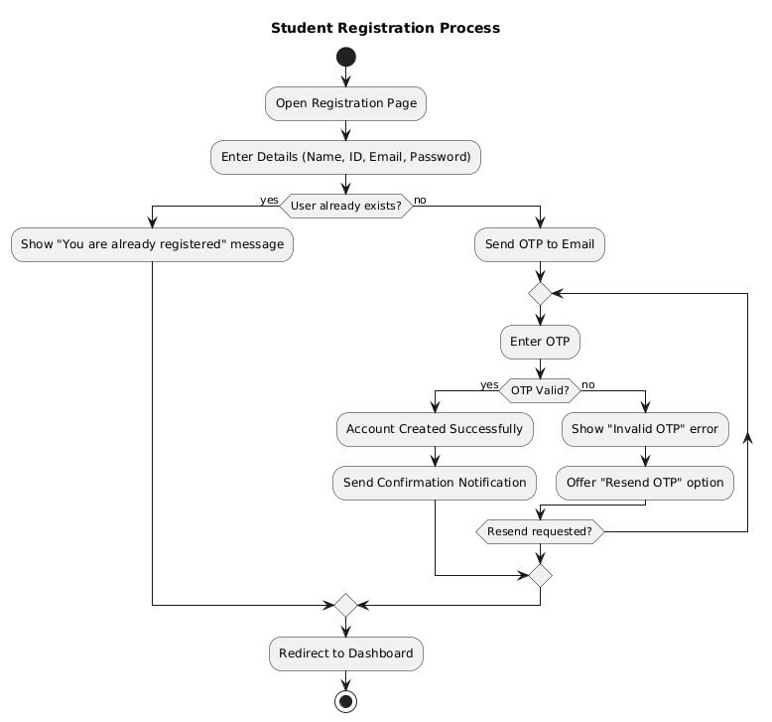

Figure-1: Student Registration

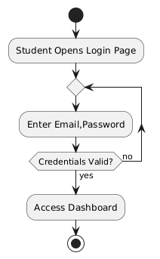

Figure-2: Student Login

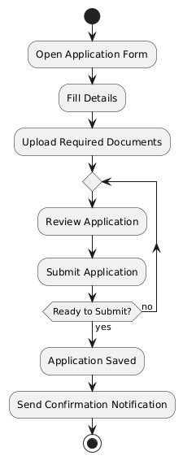

Figure-3: Apply Process

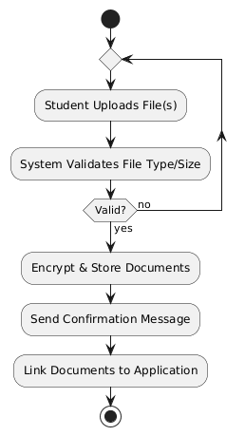

Figure-4: Upload Document

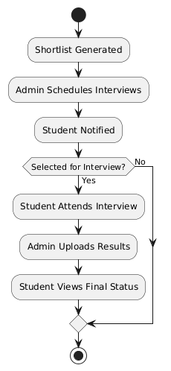Figure-5: Student Interview
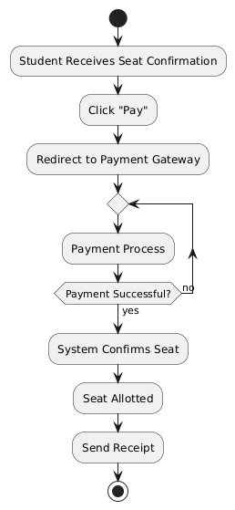

Figure-6: Payment

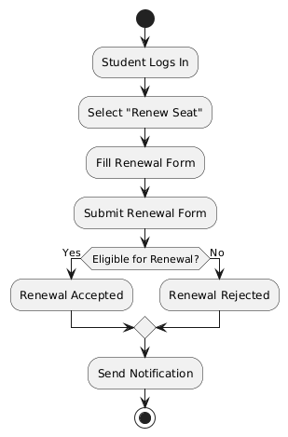Figure-7: Renewal Seat
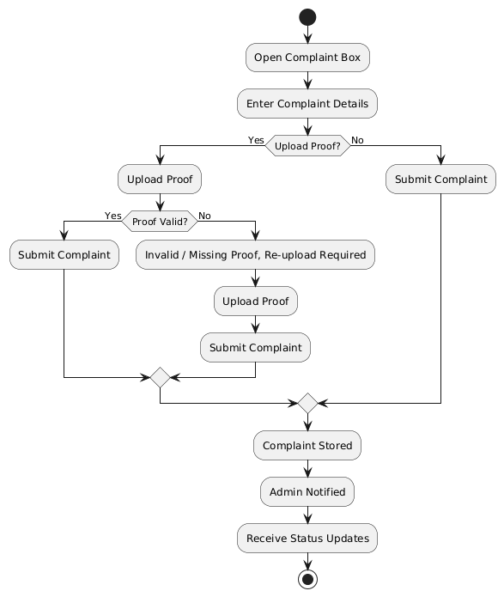Figure-8: Student Complaint
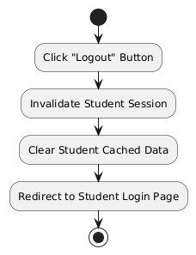

Figure-9: Student Logout

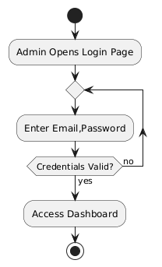
Figure-10: Admin Login
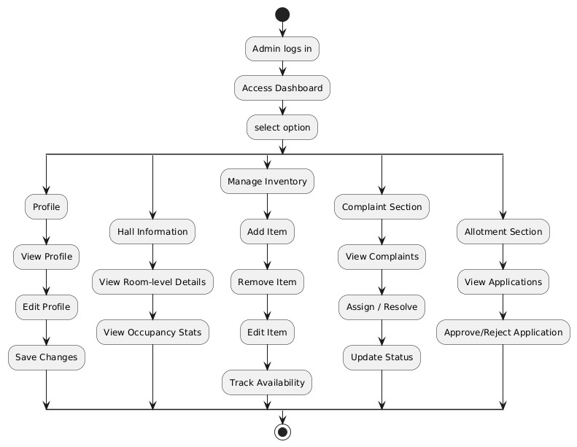

Figure-11: Admin Dashboard

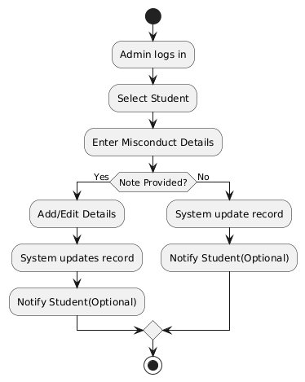Figure-12: Admin Discipline
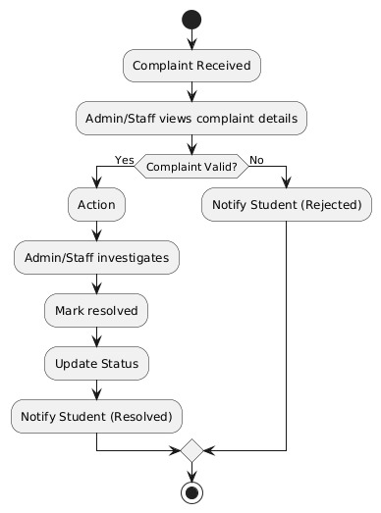Figure-13: Admin Complain Management
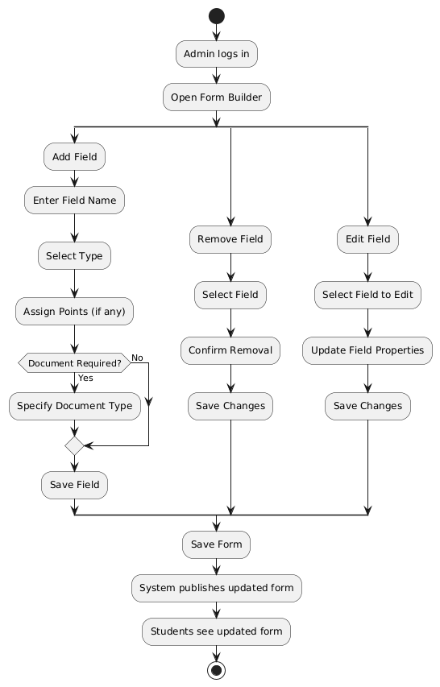Figure-14: Application Form
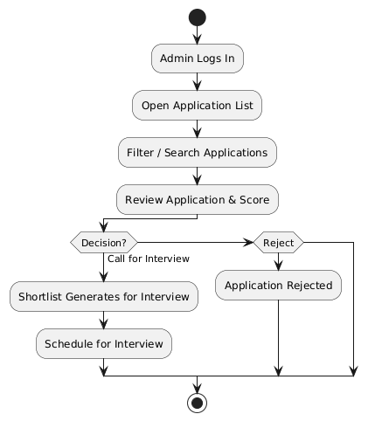Figure-15: Admin Application Manage
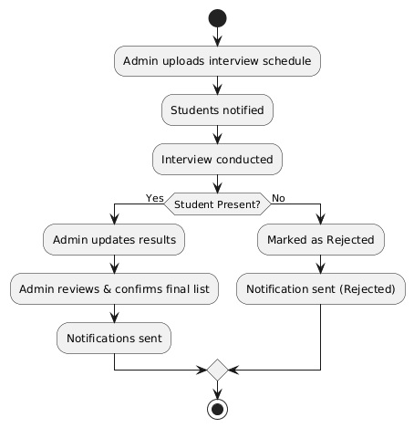

Figure-16: Interview Manage

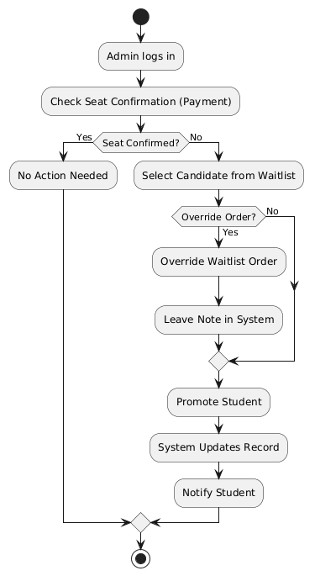Figure-17: Wait List
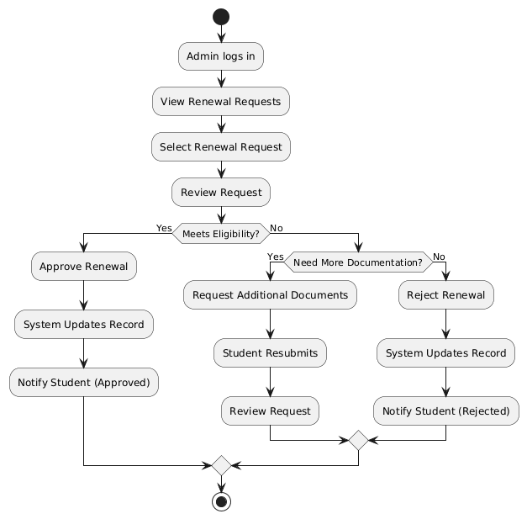

Figure-18: Admin Renewal



Figure-19: Admin Override

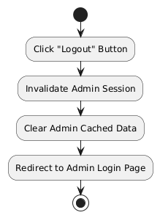

Figure-20: Admin Logout

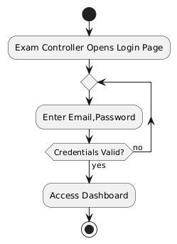

Figure-21: Exam Controller Login

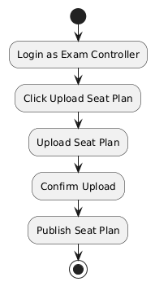

Figure-22: Upload Exam Hall Seat Plan

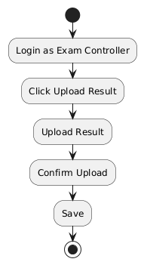

Figure-23: Result Upload

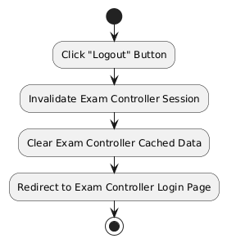

Figure-24: Exam controller Logout

9. Sequence Diagram
Sequence diagrams will detail interaction order for critical use cases.

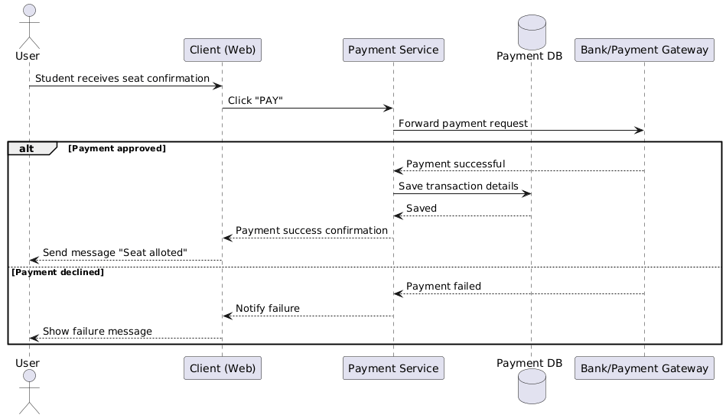

Figure-1: Student Registration

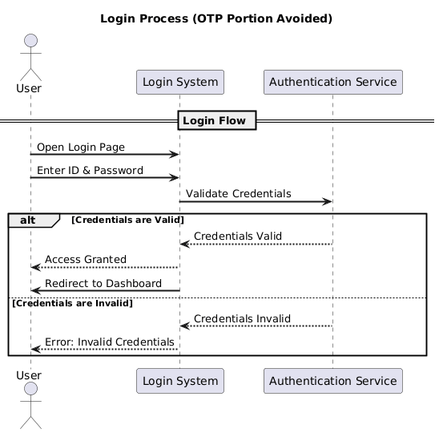

Figure-2: Student Login

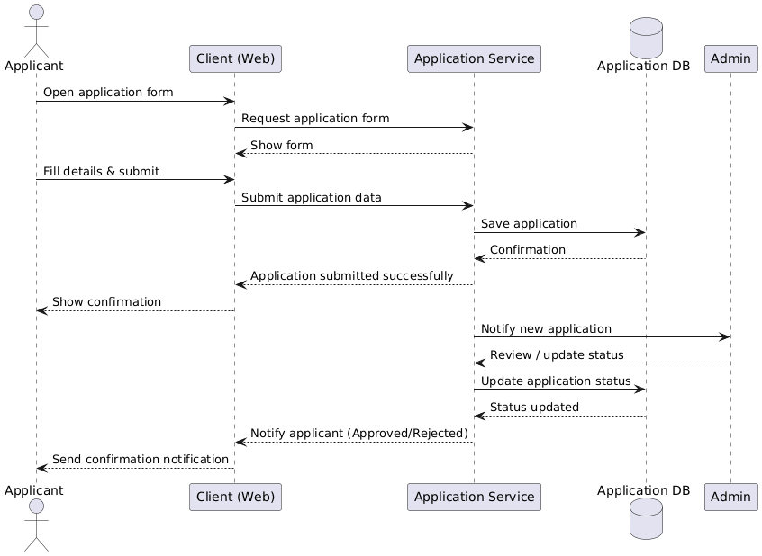

Figure-3: Apply Process

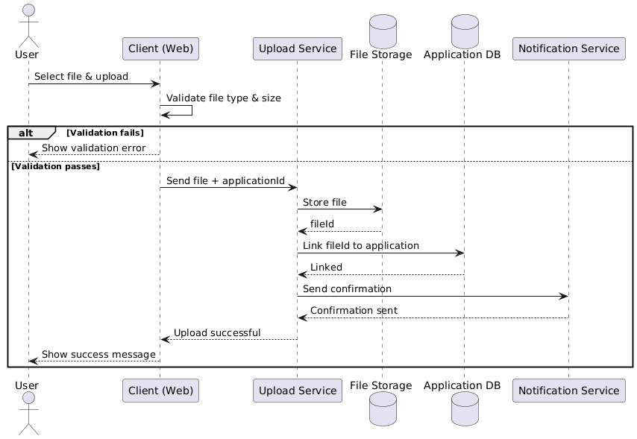

Figure- 4: Upload Document

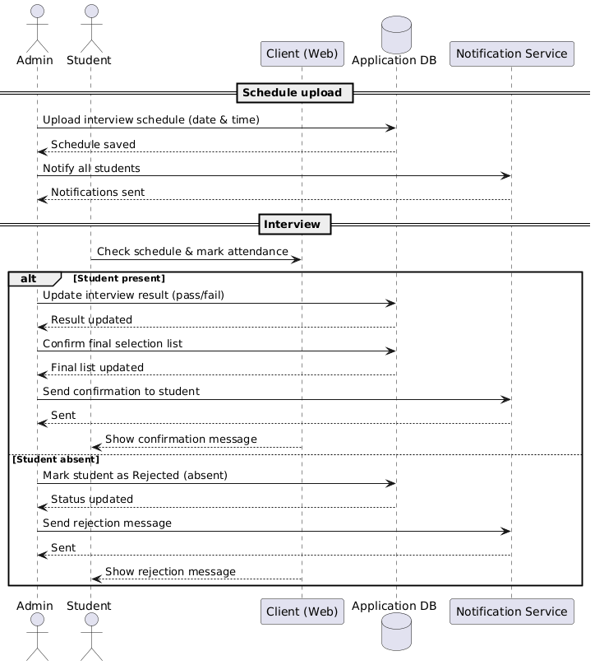

Figure-5: Interview



Figure-6: Payment

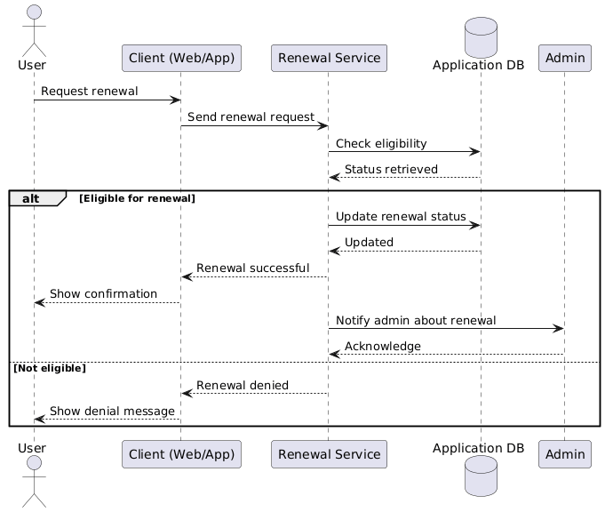

Figure-7: Renewal Seat

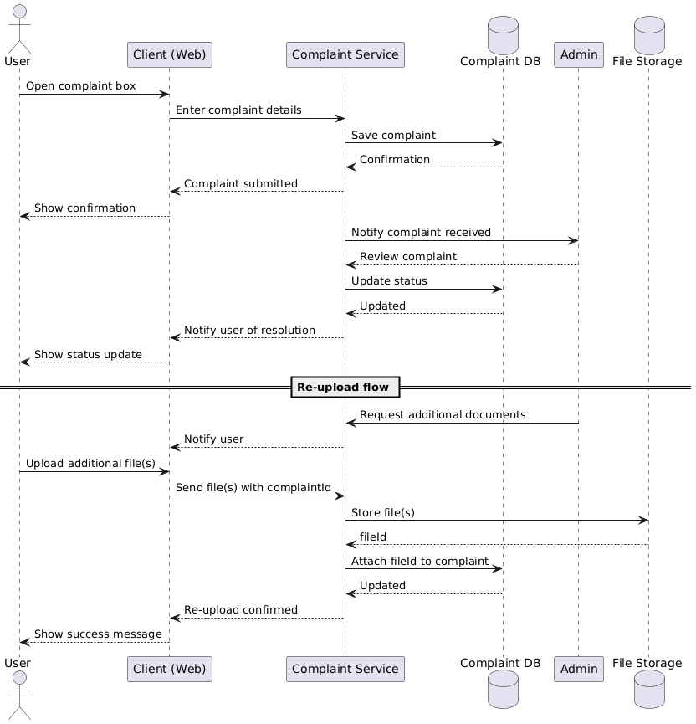

Figure-8: Student Complaint

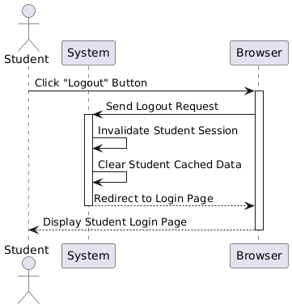

Figure-9: Student Logout

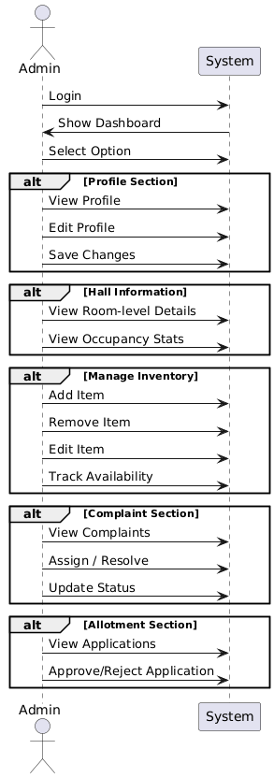

Figure-10: Admin Dashboard

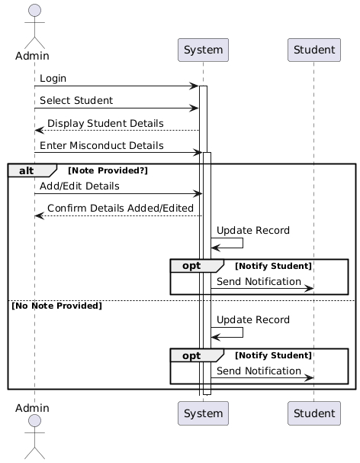

Figure-11: Admin Discipline

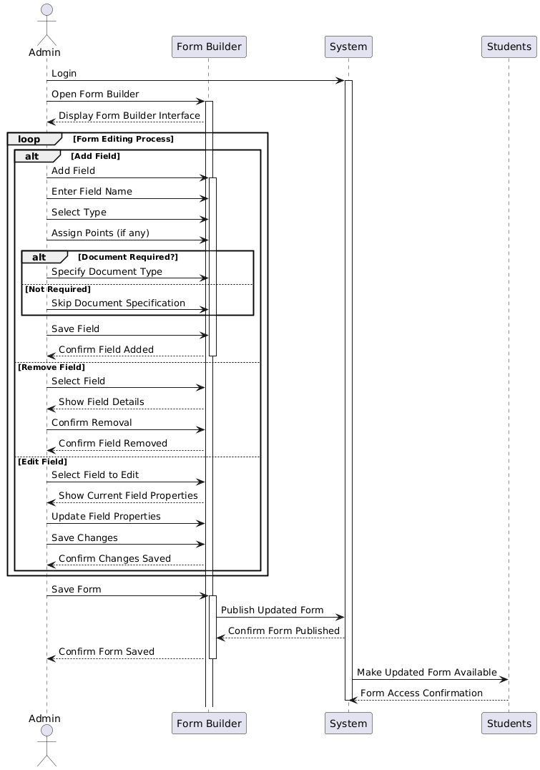

Figure-12: Admin Application Form



Figure-13: Admin Application Manage

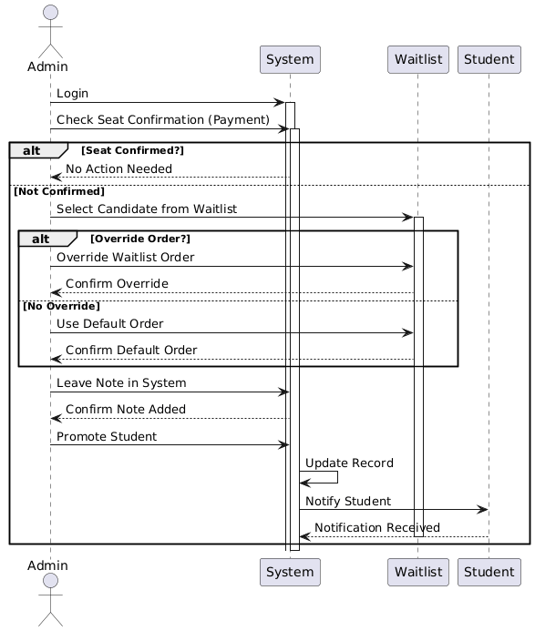Figure-14: Waitlist
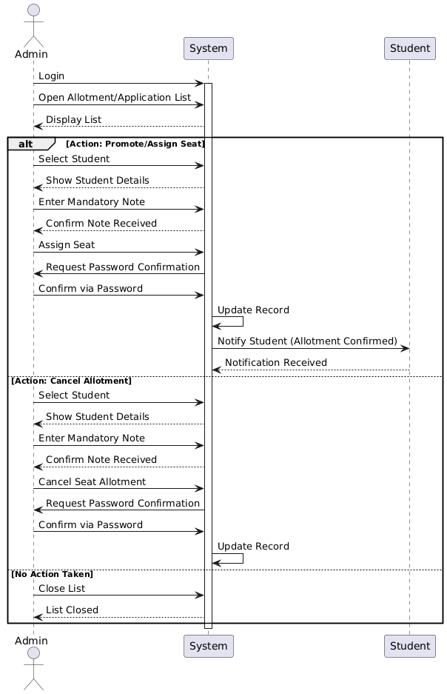Figure-15: Admin Override
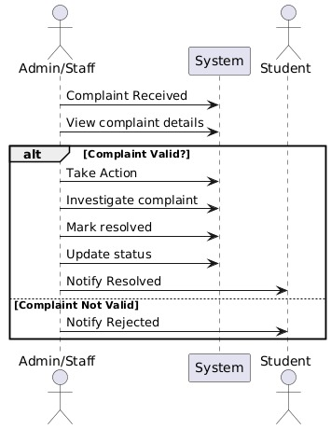
Figure-16: Admin Complain Management
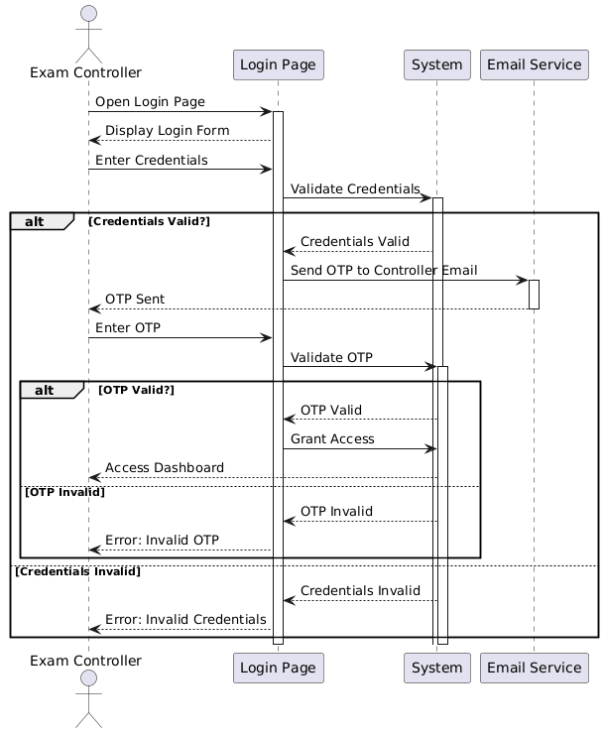

Figure-17: Exam Controller Login

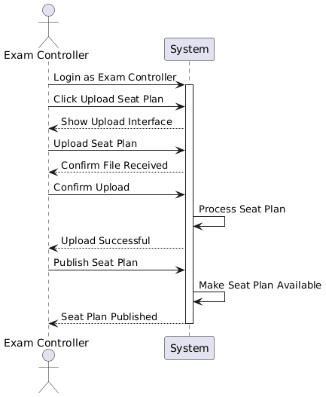

Figure-18: Exam Controller Seat Upload

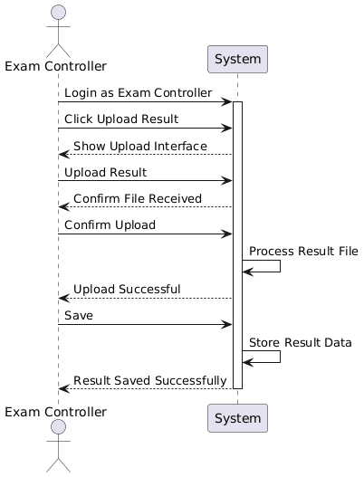

Figure-19: Exam Controller Result Upload

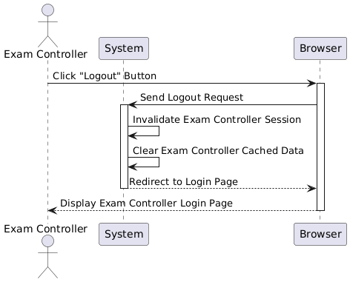

Figure-20: Exam Controller Logout

10. Class Diagram
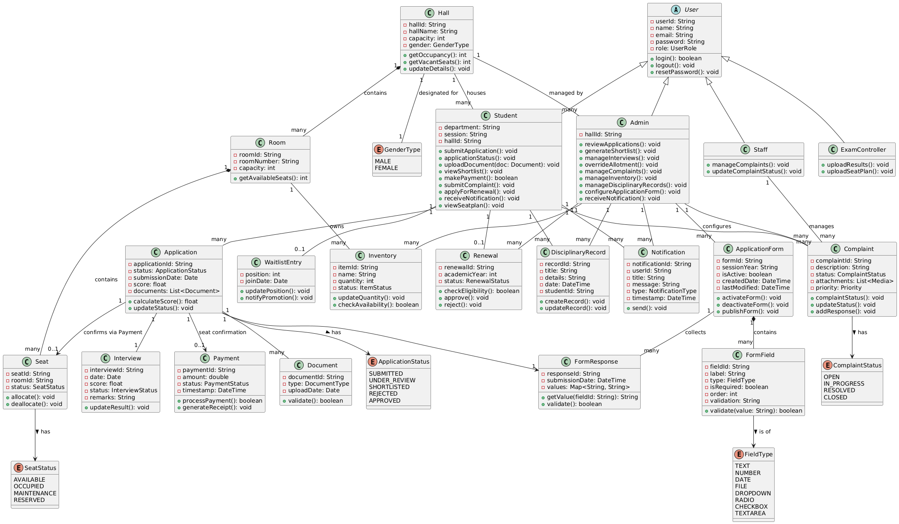

11.Database Schema
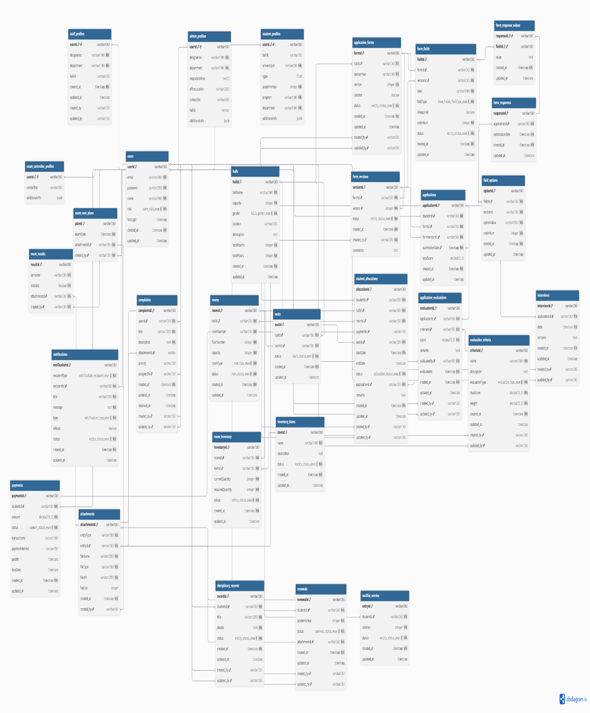Figure-1: Full Database
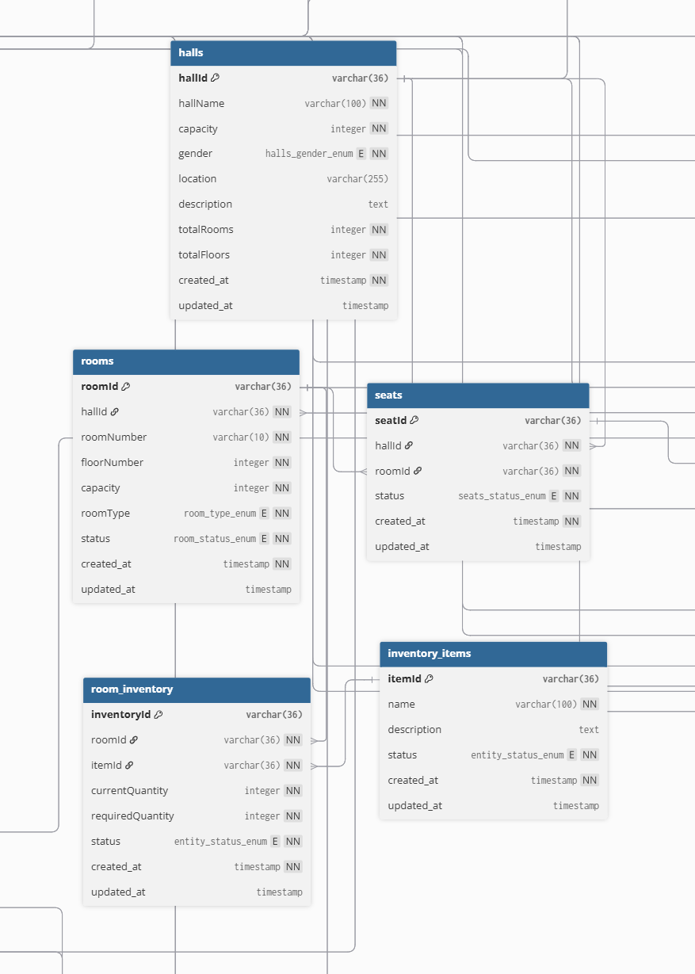
Figure-2: Hall Part
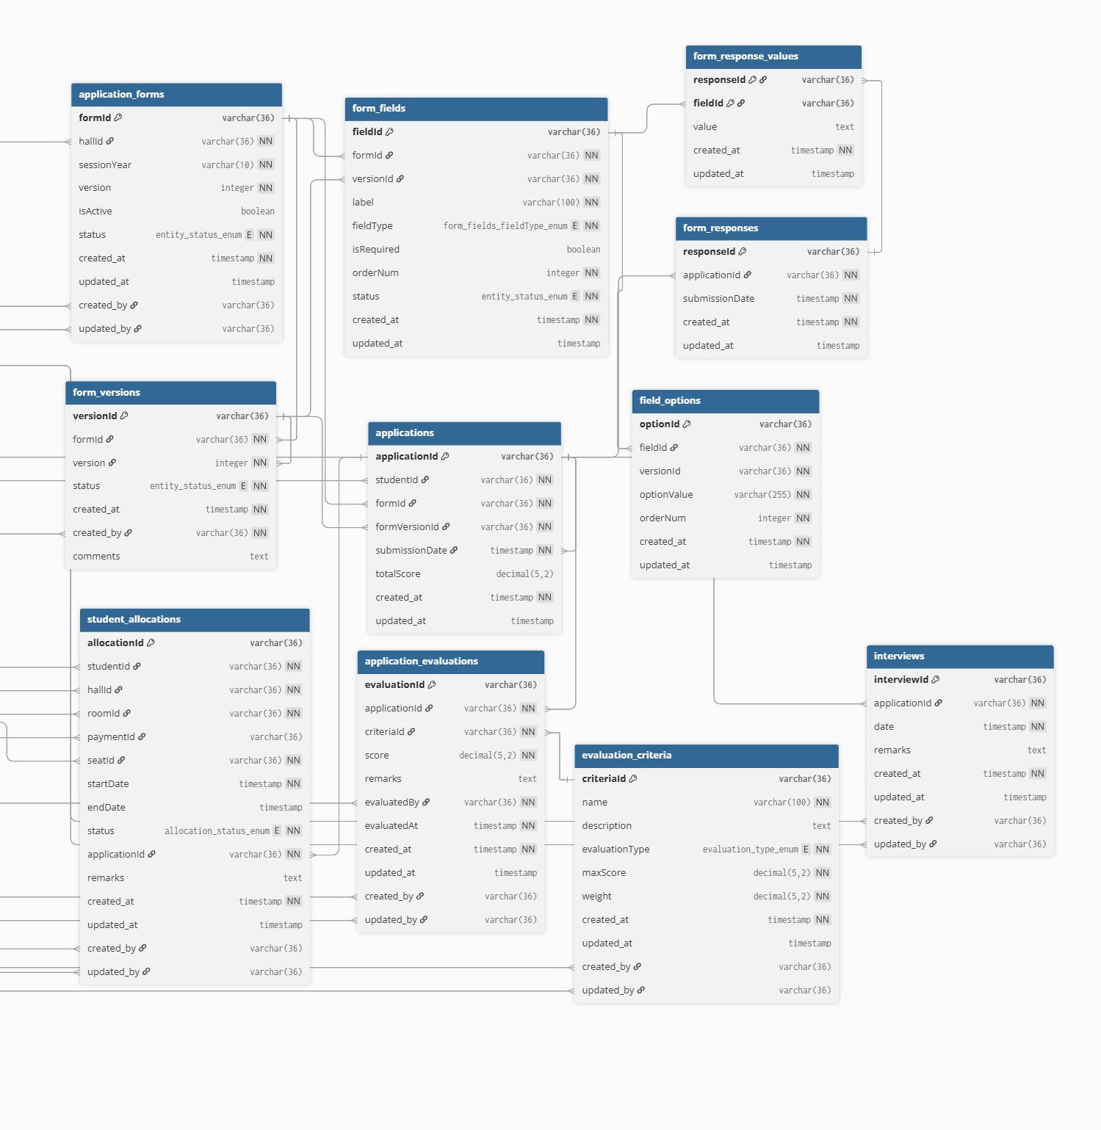

Figure-3: Allotment Part

12. Requirement Traceability Matrix
Requirement ID | Requirement Description | Functional Req. | Use Case(s) | Status
REQ-001 | Student Registration & Login | FR-001 | UC-01, UC-02 | Pending
REQ-002 | Hall Application Submission | FR-002 | UC-03 | Pending
REQ-003 | Document Upload | FR-003 | UC-04 | Pending
REQ-004 | View Shortlist & Interview Notification | FR-004, FR-005 | UC-06, UC-07 | Pending
REQ-005 | Seat Confirmation & Payment | FR-006 | UC-09 | Pending
REQ-006 | Waitlist Access | FR-007 | UC-08 | Pending
REQ-007 | Submit Complaint/Feedback | FR-008 | UC-10 | Pending
REQ-008 | Renewal Request | FR-009 | UC-05 | Pending
REQ-009 | Student Notifications | FR-010 | UC-11, UC-06, UC-07, UC-08 | Pending
REQ-010 | Administrator Login | FR-011 | UC-14 | Pending
REQ-011 | Manage Applications | FR-012 | UC-15 | Pending
REQ-012 | Automated Scoring & Shortlist | FR-013 | UC-06 | Pending
REQ-013 | Manage Interviews & Final Selection | FR-014 | UC-07 | Pending
REQ-014 | Override Allotment | FR-015 | UC-16 | Pending
REQ-015 | Manage Complaints (Admin) | FR-016 | UC-17 | Pending
REQ-016 | Track Discipline Records | FR-017 | UC-18 | Pending
REQ-017 | Manage Inventory | FR-018 | UC-19 | Pending
REQ-018 | Configure Application Form | FR-019 | UC-20 | Pending
REQ-019 | Dashboard & Reports | FR-020 | UC-21 | Pending
REQ-020 | Manage Renewals (Admin) | FR-021 | UC-22 | Pending
REQ-021 | Manage Waitlist (Admin) | FR-022 | UC-23 | Pending
REQ-022 | Administrator Notifications | FR-023 | UC-24 | Pending
REQ-023 | Upload Student Exam Results | FR-024 | UC-28 | Pending
REQ-024 | Upload Exam Seat Plan | FR-025 | UC-27 | Pending
REQ-026 | Staff Login | FR-026 | UC-30 | Pending
REQ-27 | Manage Complaints | FR-027 | UC-31 | Pending
REQ-028 | Staff Notifications | FR-028 | UC-32 | Pending
REQ029 | Staff Logout | FR-029 | UC-33 | Pending

